**Clipboard Health: Lyft Case Study**

Phillip Choi

**What is the optimal wage for airport trips in Toledo?**

The wage for drivers at which net revenues are maximized is **$19.27**. This holds true in all scenarios where the average driver is able to supply 105 rides per month. Optimal price would deviate if conditions prevent drivers from reaching this quota.

**1. How was this determined?**

A profit formula was created after modeling net revenue forecasts for the next 12 months. The equation sums the year’s forecasted net revenues as a function of wage. Per economic theory, setting the function’s derivative to 0, reveals the $19.27 wage that maximizes net revenues. The formula was attained through the following steps, testing for quality at each stage:

1. Extract useful data from reported information.
2. Solve the relationship of wage to monthly rides per driver.
3. Research external sources for insight on Toledo market.
4. List all constraints and assumptions.
5. Create Excel model forecasting drivers, riders, and ridership over 12 months.
6. Convert rides for each month into expected net revenues.
7. Identify trend in revenue streams to build a comprehensive formula.

The model attempts to emulate Toledo’s real-world environment, but limited data compels assumptions that affect accuracy. For simplicity, the profit formula was reduced to earnings from the average driver, which by definition represents all drivers collectively. Thus, the optimal wage for the average driver is the optimal wage for Toledo.

**2. Explain more about the profit formula.**

After estimating driver counts, monthly net revenues were found by first multiplying by average routes driven then by Lyft’s earnings per route. A relationship was found when comparing month-over-month revenue growth. For any set wage, revenue grows at the exact same rate as driver growth. Every month’s revenue is a product of the last, all the way to the beginning. The profit formula is basically a summation series where each of the revenues are dependent on the initial month. As mentioned in Question 1, it can further reduce to net revenue of the average driver to simplify calculating the optimal wage.

**3. What is the profit formula for Toledo’s average driver?**

For the forecasted model, annual net revenue of each driver as a function of wage is:

$\overline{NR}\left(w\right) = −237.16w^{2} + 9,141.25w – 80,309.35$ (1)

where *NR* is the annual net revenue per driver and *w* is wage. The formula is a quadratic equation, the coefficients for which are explained later. Multiplying the result with the starting number of drivers returns the full year of net revenues for Toledo.

**4. How was optimal wage solved from the average net revenue formula?**

The graph of the average net revenue in Equation (1) is a parabola that opens downward, where the vertex marks the maximum revenue. Locating the vertex through a bit of calculus uncovers optimal wage:

$\overline{NR}'\left(w\right) = −474.32w + 9,141.25$ (2)

$0 = −474.32w + 9,141.25$ (3)

$w = \frac{9,141.25}{474.32} = \$19.27$ (4)

where Equation (2) is the derivative of Equation (1). Setting the derivative to 0 and solving for wage in the next two steps shows that $19.27 will attain profit maximization.

**Modeling Toledo’s Net Revenues**

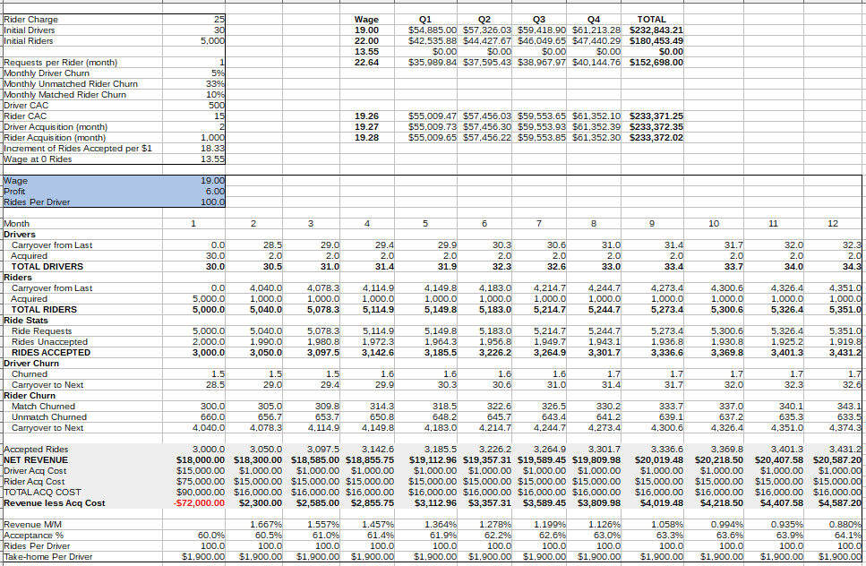

**Figure 1.** Excel model of Toledo’s forecasts over 12 months for a $19 driver wage

While the model’s foremost purpose was to understand relationships and create the profit formula, it provides secondary utilities in checking math errors, observing trends, and reevaluating new conditions or data. Possible factors that were ultimately ignored from the profit formula were kept in the model for completion. For example, CAC was not factored under the assumption that marketing costs stay constant, but the model still tracks acquisition costs for future-proofing purposes; it is easily adjusted should Lyft ever alter the marketing budget. Covered in this section are all but the last step listed in Question 1.

**4. How was the model created?**

Data extracted from the case study prompt and from external sources provided initial customer activity. Churn data was given but acquisitions were not. As a substitute, both groups grow at a fixed, arbitrary rate to somewhat maintain customer levels. Updated counts of each month’s active customers determine ridership levels.

Next, solving the relationship between wage and monthly routes per driver converts active driver counts into total rides accepted. Ridership is entirely dependent on the number of drivers, at least in this model where supply never exceeds demand, more on this later. The wage to supply connection was indirectly provided in the prompt and translated into a useable form. Lastly, financial results are obtained by multiplying total rides and Lyft’s revenue portion, ie. $25 minus wage.

**5. How was the model initialized?**

Outside sources were consulted to explore passengers flying through Toledo Express Airport (TOL), as well as Lyft’s average market share. Toledo-Lucas County Port Authority’s most recent [report on TOL passenger traffic](https://www.toledoport.org/media-room/press-releases/news/2020/january/toledo-express-airport-reports-169-percent-increase-in-passenger-traffic-for-2019/) shows 245,389 flew in pre-Covid 2019. Assuming operations have resumed, about 20,000 fly every month. Estimating Lyft’s market share, Uber has a presence to compete against, as well as buses, taxis, car rentals, personal vehicles, etc. Transportation preference data was not found. For rideshare, Statista states [Lyft captured about 30%](https://www.statista.com/statistics/910704/market-share-of-rideshare-companies-united-states/) over the same pre-Covid period. Assuming roughly 50% of passengers use rideshare, Lyft should complete about 3,000 rides per month.

To find the wage to accepted ride relationship, 60% of requests were accepted when wage was $19 and drivers accepted 100 routes per month. Completing the estimated 3,000 rides per month at 60% requires 5,000 requests, 1 for each of the 5,000 active riders. Supplying those 3,000 rides were 30 drivers each driving 100 routes. When wage rose to $22, requests were 93% filled, or 4,650, assuming the same group of drivers and riders. Each driver increased monthly routes by 55 to account for the 1,650 difference. Every $1 increment entices the average driver to take 18.3 more or fewer routes, assuming a linear relationship. All 5,000 requests would be accepted at a wage of $22.64 and no rides accepted at $13.54.

**6. How were customer levels forecasted?**

Drivers churn at 5% each month. Riders churn at 10% if they match and at 33% for those unable. Acquisition rates were not provided but the model assumed 2 new drivers and 1,000 new riders each month. This rate offsets churn to simulate a stable increase in both customer groups over time.

**7. Were there other assumptions unmentioned so far?**

A crucial assumption was that the change in accepted requests from 60% to 93% were due solely to the $3 increase in wage. Another concern, briefly mentioned, is that drivers could theoretically saturate demand, supplying less than desired, eg. too many drivers relative to ride requests. The lack of relevant data proved difficult to factor this scenario, so manually controlling acquisition rates prevented driver growth from oversaturating rider demand, circumventing the issue.

**8. What are each of the sections in the model?**

Fig. 2 is a close-up from the upper left box of fig. 1 which contains observed and assumed constants.

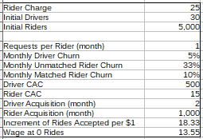

**Figure 2.** Constants for Toledo forecast

To the right of the constants in fig. 1 net revenues for selected wages are summed into quarters and full year. The blue box shown in the close-up of projected customer activity in fig. 3 are values that change depending on wage: the wage itself, Lyft net revenue, and average rides supplied. Just below the blue box are driver and rider forecasts which determine ridership and churn at the bottom.

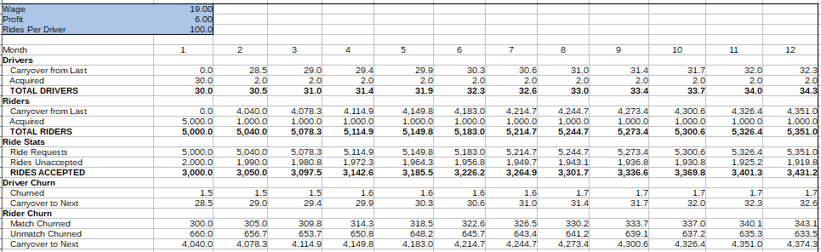

**Figure 3.** Forecast of customer activity in Toledo over 12 months

The gray financial section of fig. 4 displays the net revenue value in bold, calculated by multiplying accepted rides by profit in the blue box of fig. 3. The main objective was to maximize this row. Acquisition costs were included for completion but were not relevant to the study. The last 4 lines are performance indicators to check if the model behaves within expected parameters.

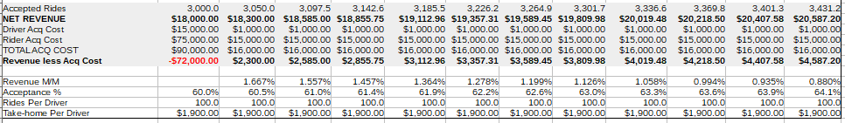

**Figure 4.** Financial 12-month forecast of Toledo

**9. Walk through an example forecast from the start.**

Continuing with the sample figures above, a driver wage of $19 gives Lyft a $6 profit. Drivers are willing to supply 100 rides at this rate. In fig. 3, the model acquires the initial 30 drivers and 5,000 riders to account for acquisition costs. Each rider requests 1 ride but the 30 drivers only accept 3,000. After the first month, 1.5 drivers churn leaving 28.5. For riders, 600 churn after not matching and 300 more who did match, or 4,040 leftover.

The initial 3,000 rides in fig. 4 are multiplied by the $6 Lyft profit to give total net revenues of $18,000 in the next line. Acquisition costs are calculated in the following 3 lines by multiplying acquisition numbers with CAC. The last financial line calculates revenue after marketing costs.

For the bottom statistics, the first month-over-month comparison is left blank as there is no previous period. Next, 60% of requests were accepted and each driver contributed 100 rides, taking home $1,900. In the next month, drivers and riders grow to 30.5 and 5,040, of which 2 and 1,000 are newly acquired, respectively. Lyft should earn $18,300 from the 3,050 accepted rides. Revenue grows by 1.7% in the second month and acceptance rate improves to 60.5%. The process is repeated until the 12th month.

**10. How was the profit equation formulated?**

A trend was found in the month-to-month net revenue growth. As long as driver growth remains constant and market conditions do not cap supply, revenue always grows at the same rate as driver growth. The first line in fig. 5 is the growth rate of the model and copied from the ‘Revenue M/M’ line in fig. 4. For any wage set in the model, revenue always grows at these specific rates.

**Figure 5.** Calculating coefficients of Toledo’s profit function

The connection between revenues implies a formula exists describing the 12-month total as a function of wage. Per Question 1, the function can further reduce to average net revenue, or net revenue per driver. To start building, first find the equation for the initial month 0:

$\overline{{NR}_{0}}\left(w\right) = \left(charge − w\right)\left(ridesperdriver\right)$ (5)

where *NR* 0 is initial net revenue per driver and *w* is wage per ride. Charge is always $25 per ride and the rides per driver is itself a function of wage:

$ridesperdriver = \frac{55}{3}w – \frac{745}{3}$ (6)

Equation (6) describes the relationship of rides supplied for any set wage. Drivers increment their accepted rides by 18.3 for every dollar, or 55/3. If it were possible to drive negative routes, drivers would supply -745/3 at a wage of 0. To test, plugging in $19 and $22 returns 100 and 155 rides per driver, as determined in Question 5. Equation (5) now yields the quadratic equation:

$\overline{{NR}_{0}}\left(w\right) = −18.3w^{2} + 706.7w – 6,208.3$ (7)

As mentioned earlier, net revenue for the second month always grows by 1.67%, so each coefficient in Equation (7) is multiplied by 1.0167. The first column in fig. 5 is the initial coefficients of Equation (7). Every subsequent column shows updated coefficients from the previous month’s. The last column sums each line and are the final coefficients of the quadratic equation back in Equation (1), which led to solving for optimal wage in Question 3.

**Conclusion**

Solving the case study was actually much simpler than the methodology here suggests. The information provided in the prompt was enough to build the profit formula. However, creating the model helped organize all possible factors and examine their relationships. It minimizes errors by checking math and, in general, projects should always deliver flexible solutions. If reality were to deviate from conditions in the model, having the math already built-in simply requires updating input values, without the hassle of solving a new formula.

**11. What improvements can be made?**

A minor improvement for the profit formula is to sum *present* values of projected revenues rather than notational value. By considering dollar inflation, discounting cash flows to their value today offers a better comparison of wages. The 12 months of revenue were too short to include it here, but exploring longer time horizons may necessitate a new revenue function.

Most other improvements regard model accuracy, attained through additional data and research. Studies should prioritize wage effects on acquisition rates and churn. The model considers them independent when in reality, a higher wage would likely boost driver counts and reduce churn, except in cases where too high a wage leads to unmet targets and an opposite effect on acquisition and churn. Therefore, all possible scenarios and effects should be thorougly analyzed for a fully comprehensive model.

**12. Are there opportunities that can spin off from these results?**

Continuing the emphasis on full comprehension, the model should forecast and strategize tail-risk events. The staggering effect on ill-prepared companies during the recent Covid lockdown is a warning to never assume stability. Constant evaluation of risks and modeling them to plan countermeasures will minimize devestation.

Lighter spinoff opportunities include applying the model to other regional launches or adding more routes in Toledo. For the latter, each new route would alter the optimal wage of existing routes in order to achieve overall network optimality. Lastly, an opportunity that offers more immediate benefits is to price driver wages in app instantaneously. Converting the model’s logic into code and wiring real-time data streams into the algorithm would automate optimality behind the scenes.

**13. Are there any concerns with adopting this wage policy?**

A wage that maximizes revenue is not necessarily always optimal, especially in short-term evaluations. What could be considered an optimal wage from Lyft’s perspective might upset top earning drivers. The model assumes all drivers are created equal when, in fact, reliability and quality will vary greatly. The issue could eventually snowball into churning out the best drivers and relying on new and/or poorer quality drivers. Second-order effects need to be studied carefully in both the short and long-term before employing any new policies.

**Appendix**

**A. Notes**

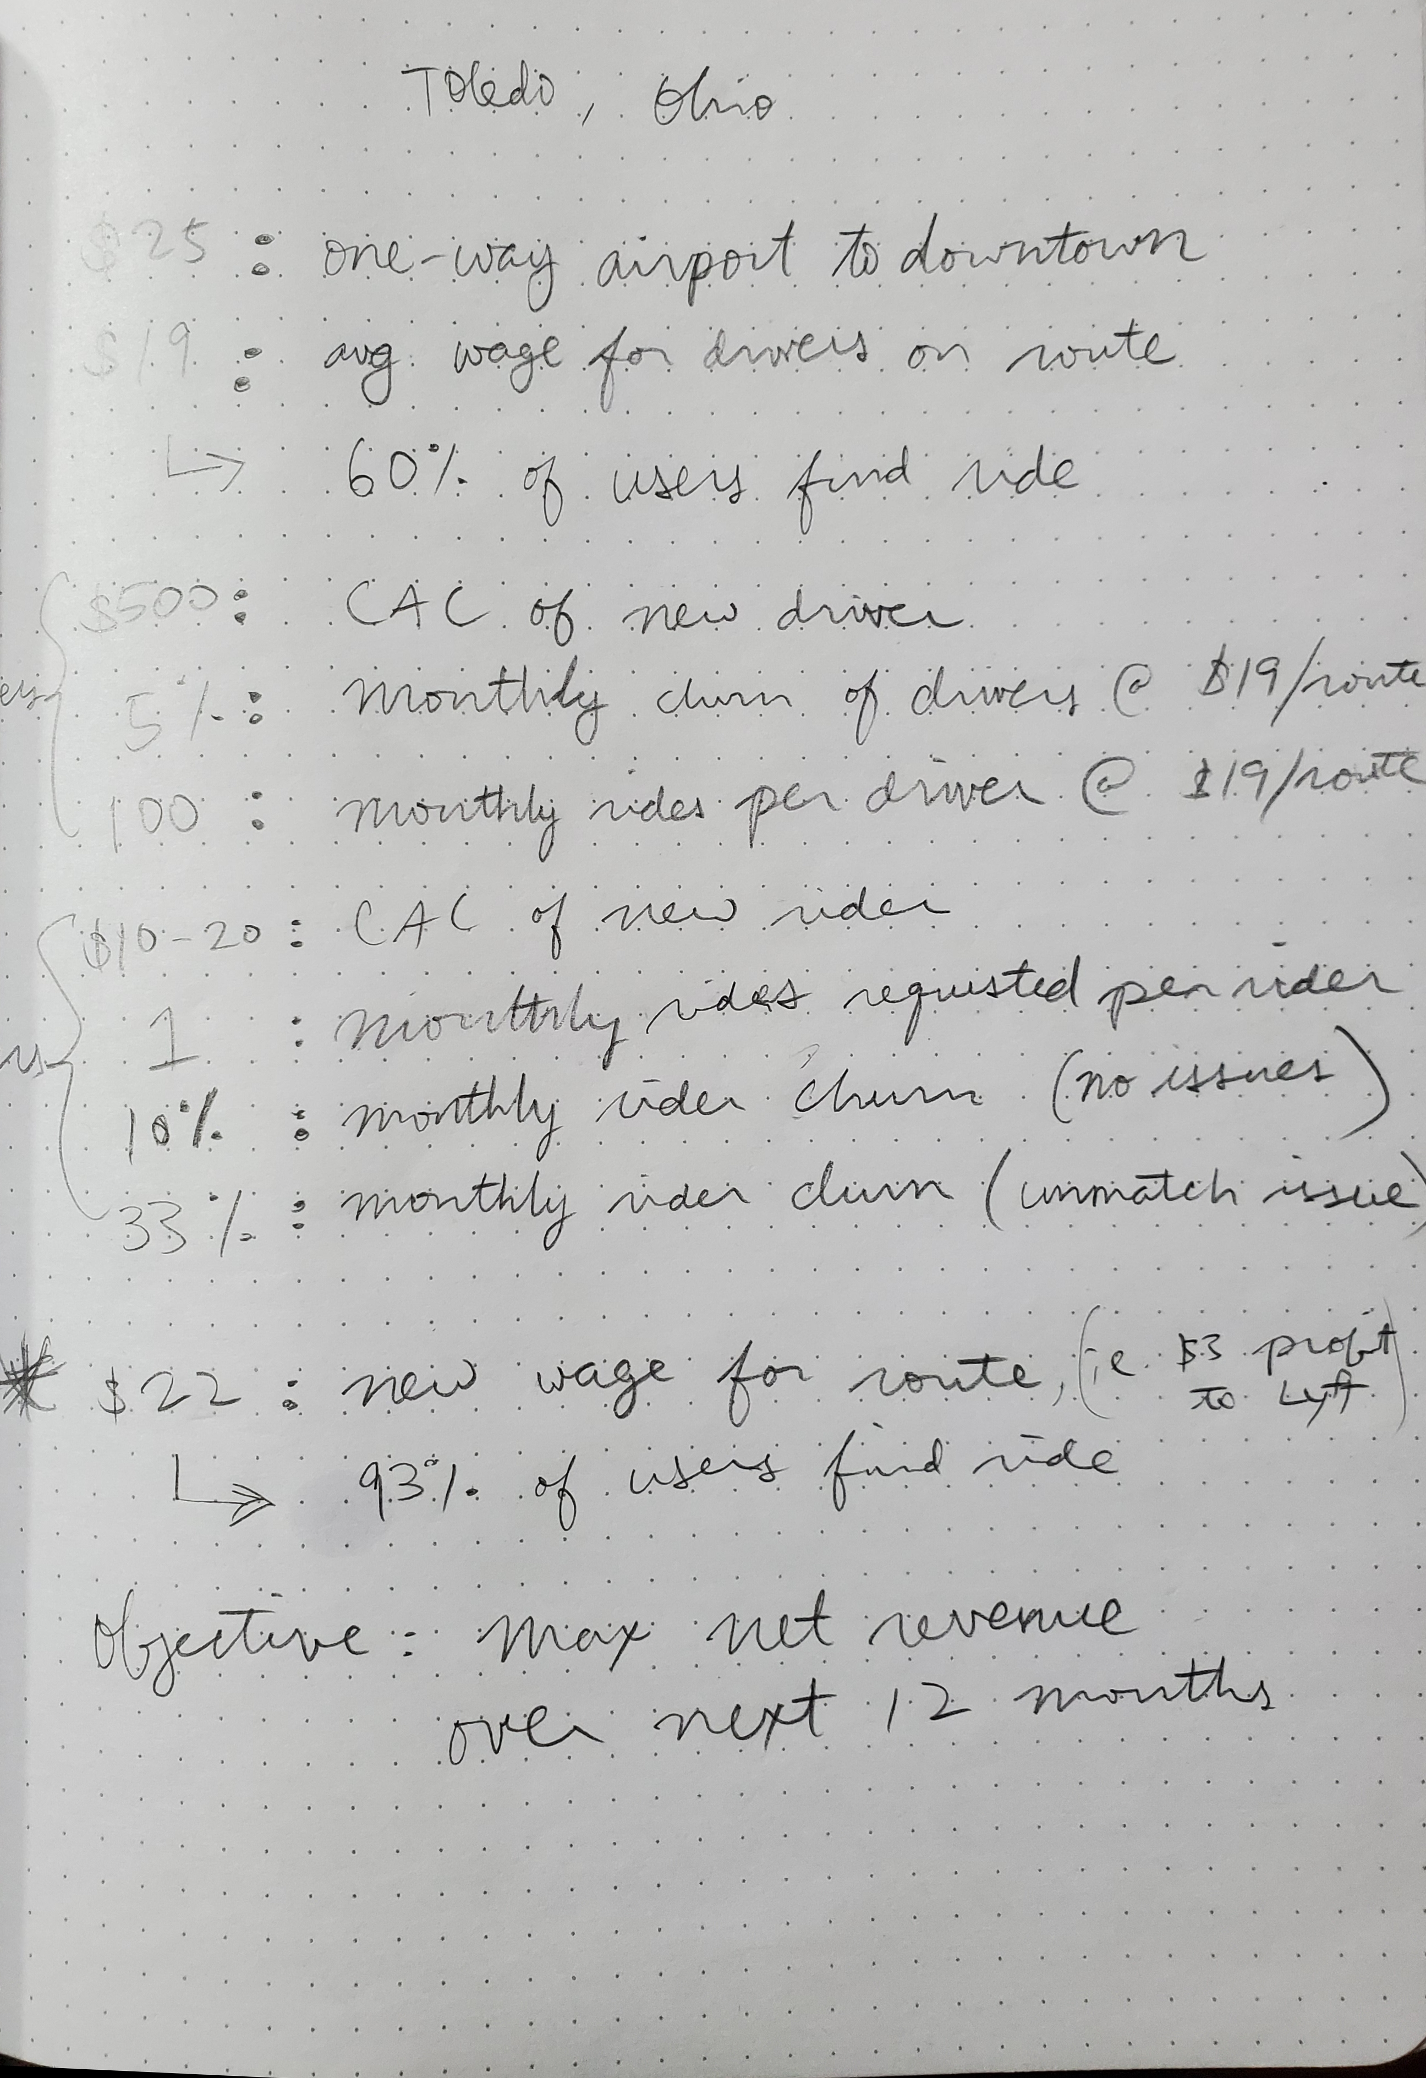

**Figure A.** Information collected from prompt

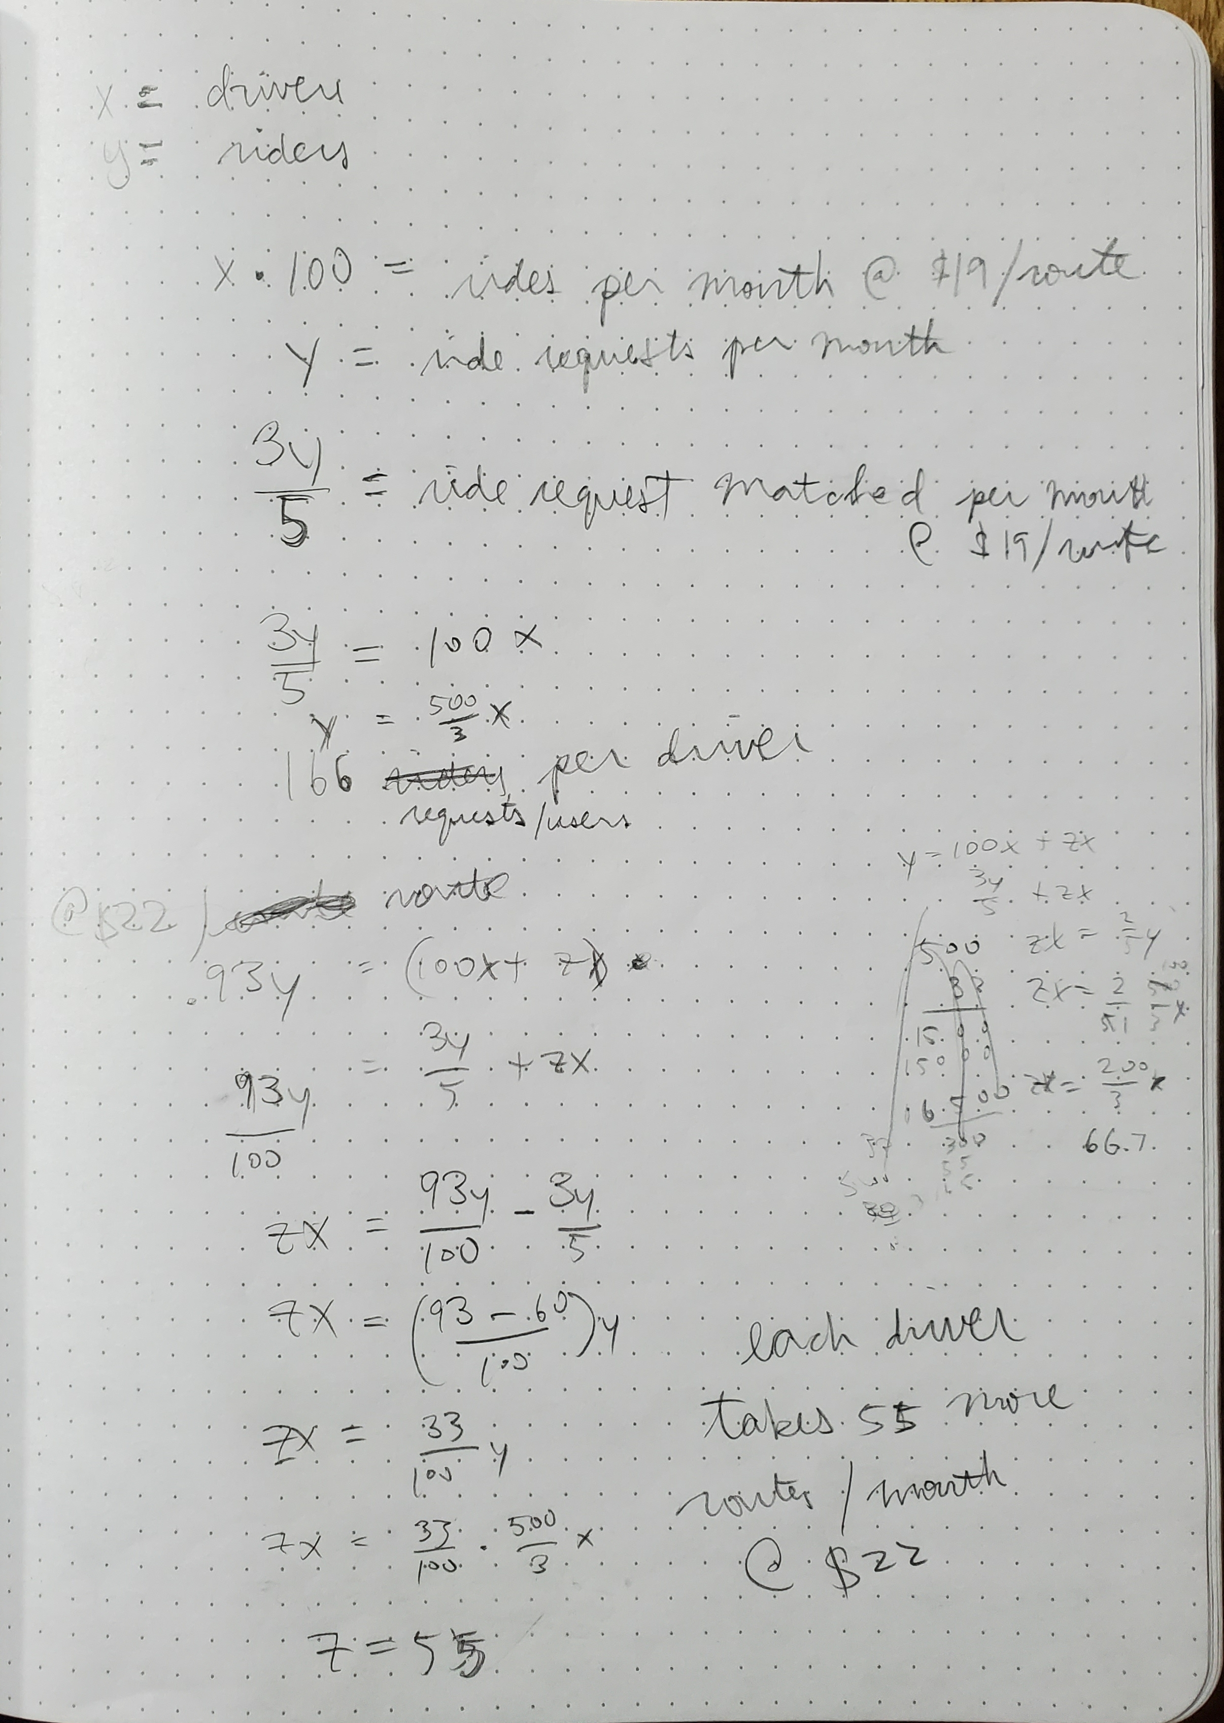

**Figure B.** Solving wage-supply relationship

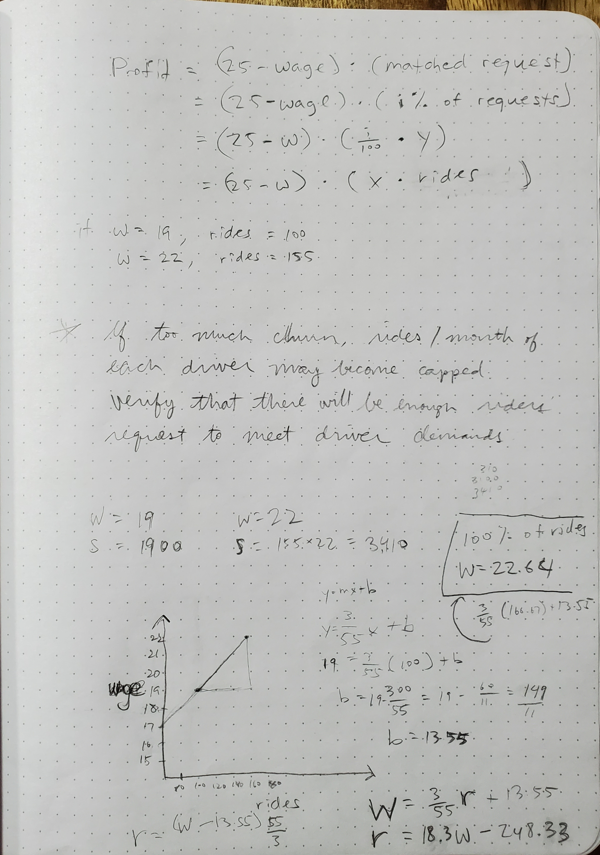

**Figure C.** Continuation of solving wage-supply relationship

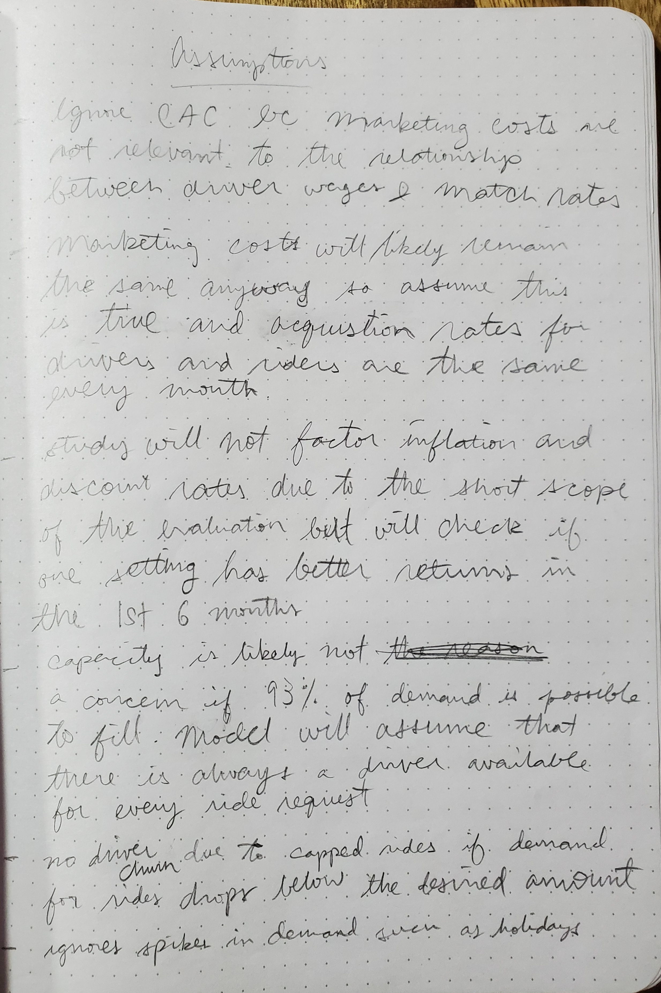

**Figure D.** List of assumptions

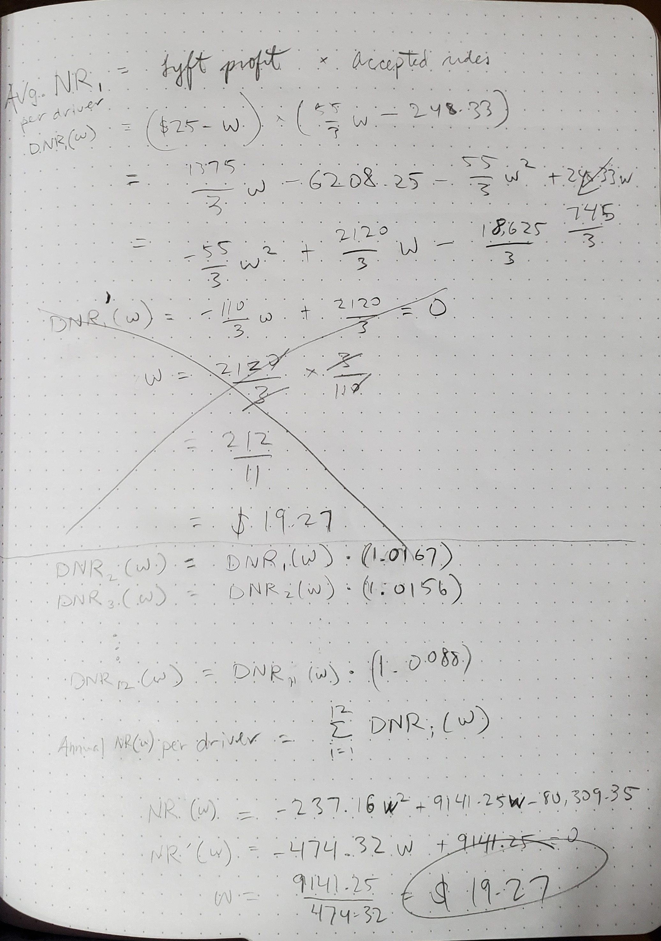

**Figure E.** Building profit formula and solving for optimal wage